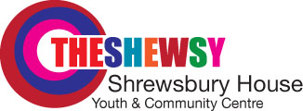
Shrewsbury House Youth and Community Centre

37 Langrove Street, Everton, LIVERPOOL, L53PE

Telephone: 0151-207-0725

A Registered charity No 1058 694 and company limited by guarantee No 3245123.

Website: www.shrewsburyhouse.org.uk Fax: 0151-207 6132

SHREWSBURY HOUSE Gift Aid Form

Please treat as Gift Aid donations all qualifying gifts of money made (please cross out statements that do not apply):

- Today
- In the past 4 years
- In the future
I am a UK taxpayer and understand that if I pay less Income Tax and/or Capital Gains Tax than the amount of Gift Aid claimed on all my donations in that tax year it is my responsibility to pay any difference.

DONOR DETAILS:

Title: First name or initial(s) and Surname:

Full home address:

Postcode:

Date:

Signature:

Please notify Shrewsbury House if you:
- Want to cancel this declaration
- Change your name or home address
- No longer pay sufficient tax on your income and/or capital gains.
The charity will reclaim 25p of tax on every £1 that you give as a donation.

If you pay Income Tax at the higher or additional rate and want to receive the additional tax relief due to you, you must include all your Gift Aid donations on your Self Assessment tax return or ask HM Revenue and Customs to adjust your tax code.

